**Lab Report**

Title: Exploring MN LiDAR and National PRISM Data

Notice: Dr. Bryan Runck

Author: Lauren Roach

Date: November 2, 2022

**Project Repository:** https://github.com/L-roach/GIS5571/tree/main/Lab2

**Google Drive Link:** N/A

**Time Spent:** 40 hours

**Abstract**

Throughout this lab, TIN, .bit, LiDAR, and DEM files were explored in the context of three problems divided into two separate lab parts. In the first part of the lab, LiDAR files from the MN Geospatial Commons were explored and edited in ArcGIS Pro; these files were explored in 2D and 3D. Afterwards, the annual 30-year Normals .bil files for precipitation from PRISM were used to create a space time cube for precipitation over 12 years.

**Problem Statement**

In the first part of the lab, the tasks involved finding the LiDAR and PRISM data and then addressing the question of how to explore this data in ArcGIS Pro and how to create a space time cube describing this data.

Table 1. Requirements for Lab 2 Part 1

|  |  |  |  |  |  |  |
| --- | --- | --- | --- | --- | --- | --- |
| **#** | **Requirement** | **Defined As** | **(Spatial) Data** | **Attribute Data** | **Dataset** | **Preparation** |
| 1 | Elevation data | Data stored as points describing the elevation in an area | LiDAR/ point data | Ground point data | MN Geospatial Commons | Convert to other formats |
| 2 | Annual precipitation data | Annual 30-year precipitation data across the continental US | Raster data | Precipitation | PRISM | Convert to other format |

**Input Data**

The data used in this part of the lab was sourced from the MN Geospatial Commons and the PRISM Climate Group. The LiDAR data that describes the elevation contains multiple points that were collected from a sensor. The PRISM data is stored in a .bil file that contains precipitation information and other attributes.

Table 2. Data used in the analysis

|  |  |  |  |
| --- | --- | --- | --- |
| **#** | **Title** | **Purpose in Analysis** | **Link to Source** |
| 1 | LiDAR data in .las format: 4342-13-07.las | The .las file was converted to a DEM and TIN | [Mn GeoSpatial Commons](https://gisdata.mn.gov/dataset/trans-roads-mndot-tis) |
| 2 | PRISM .bil file | There are 12 separate .bil files that contain precipitation information. These .bil files were added to a mosaic dataset to make the spacetime cube. | PRISM |

**Methods**

With the LiDAR data, the data was first extracted from the MN Geospatial Commons and added to the map. An LAS dataset was created using arcpy and then this dataset was added to a raster. As a DEM file, this raster was then converted to a TIN file. The values of the TIN raster were adjusted over a couple iterations to explore how changing z-values and max points changes the raster.

Figure 1. LiDAR data conversion to TIN

Figure 2. Data flow diagram of Part 1

In the second part of this section of the lab, PRISM data was extracted from the PRISM Climate Group site. Once this data was extracted, it was converted to a .tif file format. Then, a mosaic dataset was created and the 12 PRISM raster datasets were added to the mosaic dataset. Within the rasters, new fields were added to display time as a year, corresponding to one year for each .bil file from PRISM. This process was building multidimensional info. Then, a multidimensional raster layer was created and this was then converted into a spacetime cube.

Figure 3. Data flow diagram of Part 2

**Results**

The DEM and TIN exploration from part 1 produced a colorful snapshot of the elevation in one area of Minnesota, featured below. Figure 4 shows the image that is displayed in the exported PDF of the TIN and DEM files. The 3D exploration snapshot is also included.

The resulting space time cube showed a gray continental US. With more time, I would make the appropriate adjustments in my code to create an accurate spacetime cube because the code technically worked but must have the incorrect time inputs built into the multidimensional info.

Figure 4. Map: TIN display- Snapshot of exported PDF

Figure 5. TIN 3D exploration

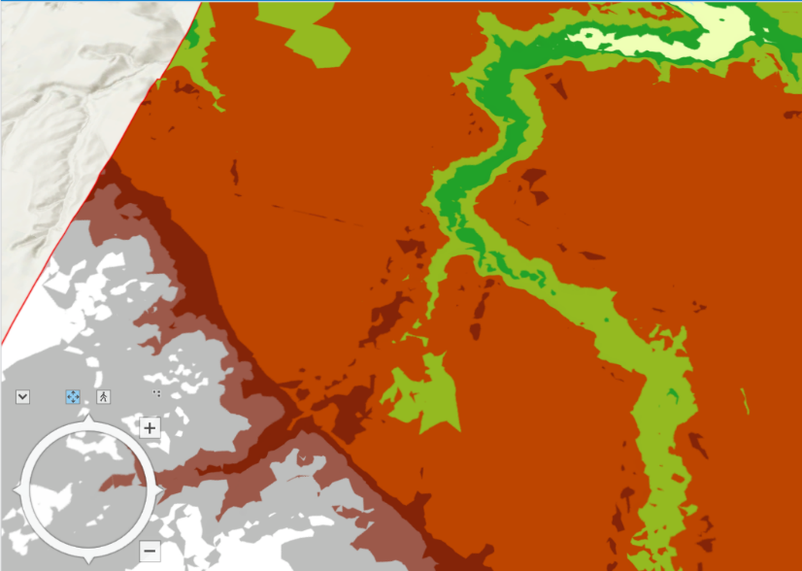

Figure 6. Original DEM file

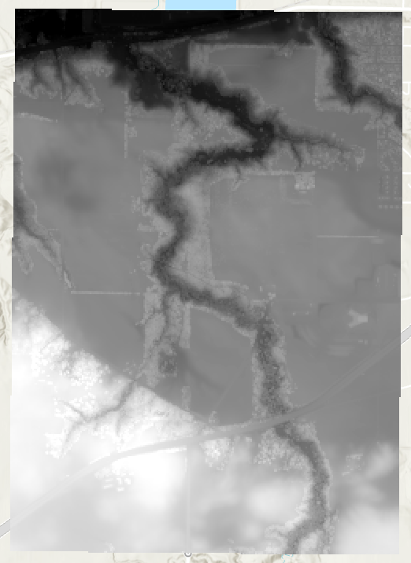

Figure 7. TIN exploration with low max points and high z value

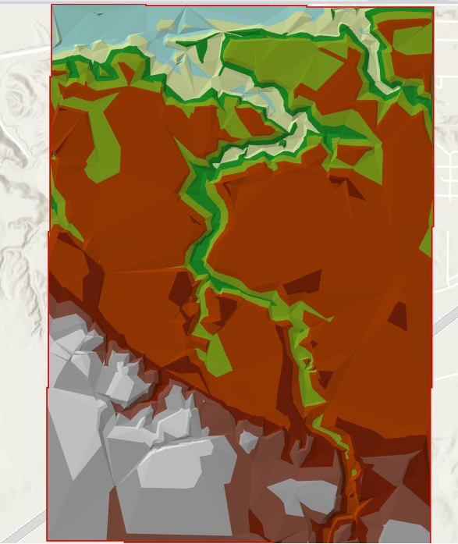

Figure 8. TIN with high z value (1000 versus standard practice of 1)

Figure 9. Spacetime Cube Result

**Results Verification**

I verified my results with a visual observation. This form of qualitative verification is appropriate for the extent of the lab problem. For the first part, the shading and color symbology of the TIN matches the type of typography expected in this area of Minnesota. For the second part of the lab, my results are not correct, and I know this through a visual inspection. The expected result is a clip of the continental US that has different symbology throughout that changes over time because precipitation changes throughout the US and over time. Thus, my solid gray overlay is incorrect. A future lab should explore what values or attributes are incorrect in the correct lines of code, since technically the space time cube tool was successful.

**Discussion and Conclusion**

Once I understood how the LiDAR files were stored in the MN Geospatial Commons, the process was simple bringing it into ArcGIS Pro and converting it to the right format to view and explore. When I changed the values for the TIN creation, this changed the amount of detail the file displayed; it took a few iterations to understand how the adjustments I was making in the values area affected the resolution of the resulting TIN. The standard practice is to utilize a z value of one because manipulations are not appropriate for this type of data when showing the actual elevation. Higher z values and lower max points lead to distorted images; the higher the z value the greater the distortion because this is warping the values on the z axis.

While I was able to load the TIN into a new local scene and source the elevation model with my TIN file using 3D, I was not able to fully explore the scene and see the TIN from different angles. Converting the LiDAR files into DEM and TIN files is a useful way of exploring elevation in particular areas. With more time, I would have further explored how to manipulate the 3D local scene to see the TIN from other angles.

Regarding the PRISM data, I first struggled to understand how to extract and/or add the time element to the mosaic dataset. While this created a significant obstacle for me initially, eventually I found the code to do this on an Esri blog. However, even though my spacetime cube was technically successful, the actual result was a gray overlay of the continental US without changes displayed. Despite my difficulties in maneuvering the .bil file format, this lab challenged me to use PRISM data.

**References**

1. “Exploring your raster data with space time pattern mining,” Esri, https://www.esri.com/arcgis-blog/products/arcgis-pro/analytics/explore-your-raster-data-with-space-time-pattern-mining/

**Self-score**

|  |  |  |  |
| --- | --- | --- | --- |
| **Category** | **Description** | **Points Possible** | **Score** |
| **Structural Elements** | All elements of a lab report are included **(2 points each)**:  Title, Notice: Dr. Bryan Runck, Author, Project Repository, Date, Abstract, Problem Statement, Input Data w/ tables, Methods w/ Data, Flow Diagrams, Results, Results Verification, Discussion and Conclusion, References in common format, Self-score | 28 | **28** |
| **Clarity of Content** | Each element above is executed at a professional level so that someone can understand the goal, data, methods, results, and their validity and implications in a 5 minute reading at a cursory-level, and in a 30 minute meeting at a deep level **(12 points)**. There is a clear connection from data to results to discussion and conclusion **(12 points)**. | 24 | **22** |
| **Reproducibility** | Results are completely reproducible by someone with basic GIS training. There is no ambiguity in data flow or rationale for data operations. Every step is documented and justified. | 28 | **24** |
| **Verification** | Results are correct in that they have been verified in comparison to some standard. The standard is clearly stated **(10 points)**, the method of comparison is clearly stated **(5 points)**, and the result of verification is clearly stated **(5 points)**. | 20 | **16** |
|  |  | 100 | **90** |